 

**Placement Empowerment Program**

***Cloud Computing and DevOps Centre***

60 Days of DevOps Challenge

***Day 5: Python Basics for DevOps***

***Name: Mary Edlyn A Department: CSE***



**Challenge 1**: Create a Python program that accepts a user’s name as input and prints a greeting message.

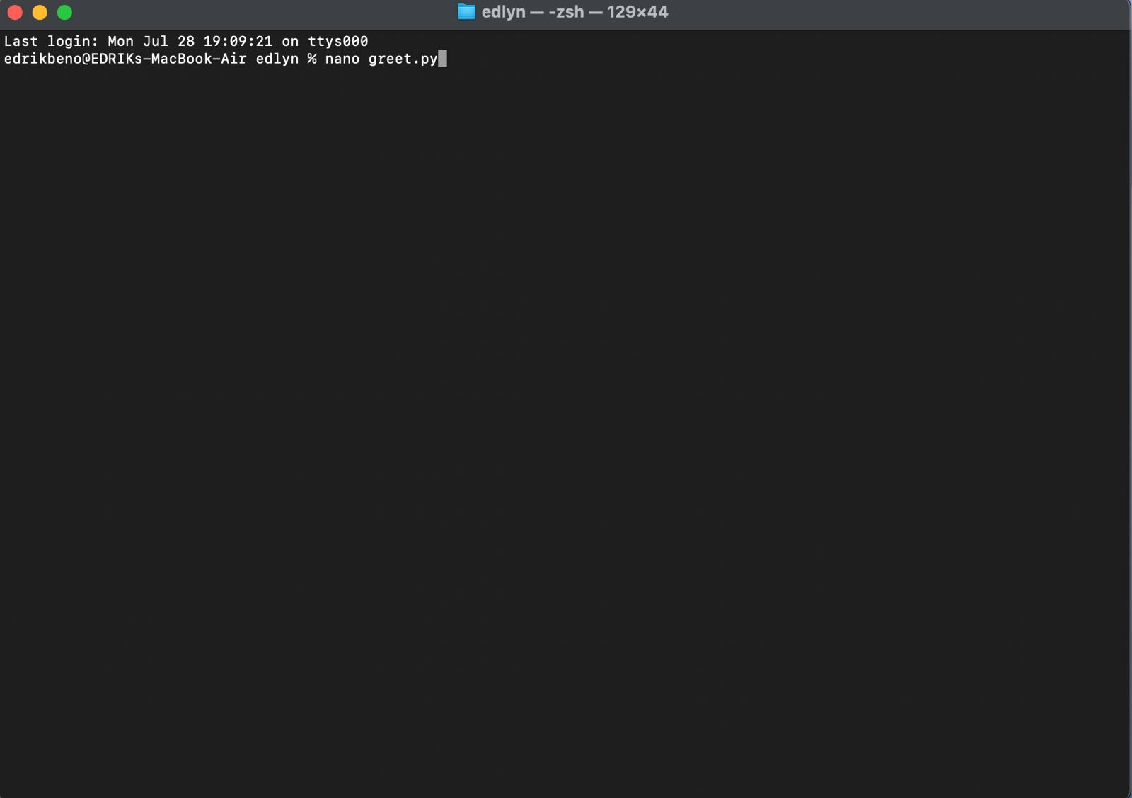

**Challenge 2**: Write a script that reads a text file and counts the number of words in it.

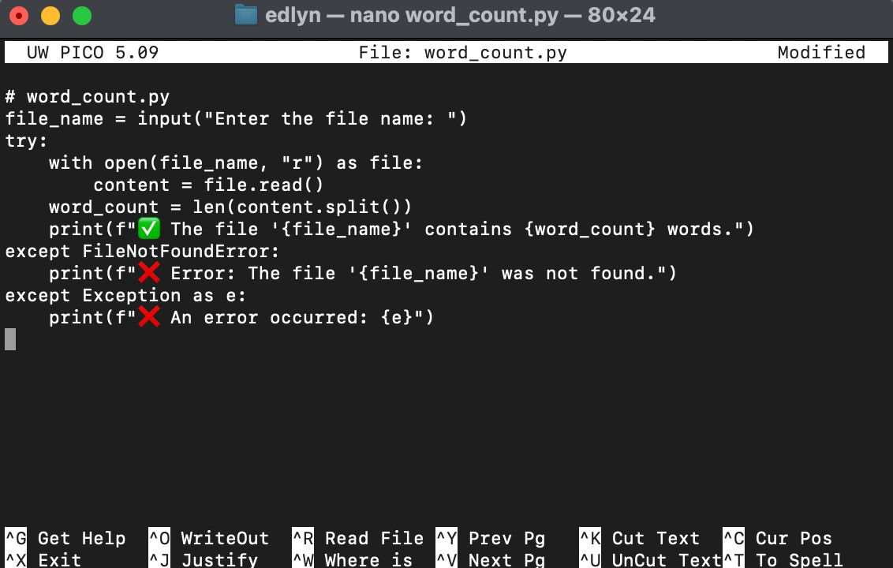 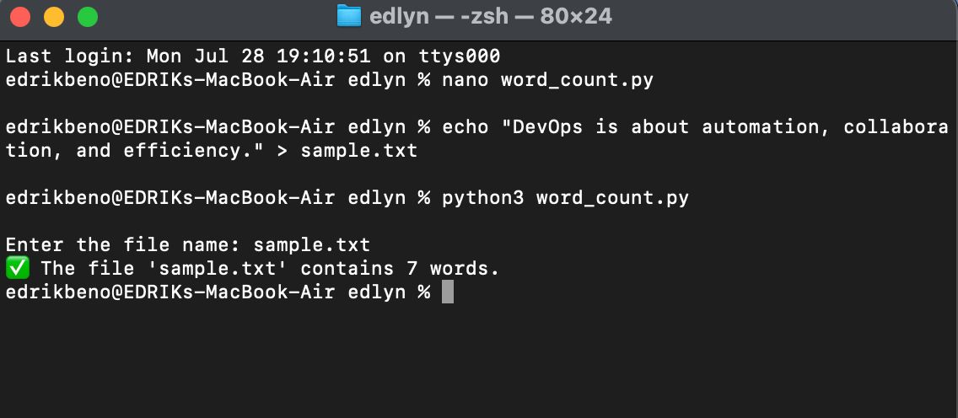

Challenge 3: Random Password Generator

